**Detailed Requirement Document**

**SMART IRRIGATION SYSTEM USING ESP32**

**Version:** 1.0

**Date:** 06-May-2024

**Drafted By:** Team A

**Document Control**

**Document Information**

|  |  |
| --- | --- |
| **Details** | **Information** |
| Document Owner |  |
| Issue Date | 06-May-2024 |
| File Name | **Detailed Requirement Document** |

**Document History**

|  |  |  |
| --- | --- | --- |
| **Version** | **Issue Date** | **Changes** |
| **1.0** | **06-Mar-2024** | **Initial Draft(v 0.1)** |
|  |  |  |
|  |  |  |
|  |  |  |
|  |  |  |

1. **Objective:**

Ensure efficient irrigation by automatically adjusting watering schedules based on real-time soil moisture data. Utilize soil moisture sensors to accurately measure moisture levels and prevent excess water usage, which can lead to water wastage and soil erosion. Automate irrigation processes to reduce the need for manual monitoring and watering, allowing farmers to focus on other important tasks.

1. **Introduction:**

The purpose of this document is to outline the detailed requirements for developing the Smart Irrigation system using ESP32. This system aims on controlling the irrigation motor based on moisture in the soil and storing the operated time of motor to SD Card based on Real Time clock. This document covers System / hardware requirements, software requirements and guidelines for implementation.

1. **Project requirement:**
   1. The system require stable power supply to power the ESP32 and other components. This could be a USB power adapter or battery pack.
   2. The system shall utilize hardware with the same configuration including RAM and ROM requirements.
   3. The smart phone is interfaced with inbuilt Bluetooth in MCU through Bluetooth application for wireless communication between MCU and Smart phone.
   4. An External SD Card of 2GB is required for storing the motor operated time.
   5. An External RTC (Real Time Clock) of same configuration is required to get the start time and stop time of motor via I2C interface and store it into SD card.
   6. ESP32 development board can't directly drives the 12 volts DC motor, we need a motor driver to control the motor. This allows the ESP32 to switch the motor on and off.
   7. To get soil moisture data to MCU we require moisture sensor.
   8. The system should allow automatic mode and manual mode through external Bluetooth terminal which control the motor operation.
2. **System/Hardware Requirements**
   1. **Hardware Specifications:**

|  |  |  |  |
| --- | --- | --- | --- |
| **Sl. No** | **Description** | **Specification** | **Values** |
| 1 | Development Environment | ESP32 | Same as existing controller hardware |
| 2 | Application processor(AP)Interface | SPI  I2C |  |
| 3 | S D card | SPI interface | 2GB |
| 4 | Soil Moisture Sensor Module |  |  |
| 5 | RTC Module | DS1307 | Same as existing  Module. |
| 6 | Motor driver | L298N | Same as existing  Module. |

1. **Block Diagram:**

A detailed block diagram illustrating the connection between ESP32 Microcontroller and interfacing devices.

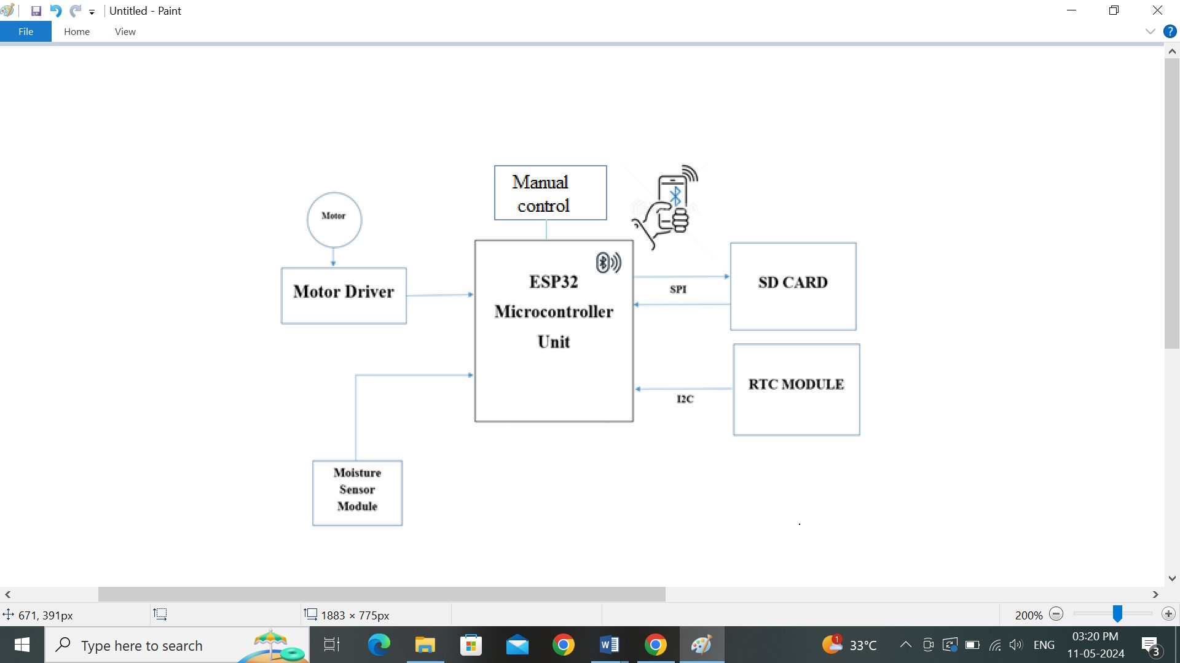

1. **SOFTWARE REQUIREMENTS**
   1. **MCU (Microcontroller Unit):**
      1. The MCU should collect the end to end continues data from moisture sensor and it should control motor operation depend on soil moisture level.
      2. Default it should operates in automatic mode and switch to manual control upon user requirement by the Bluetooth terminal.
      3. The MCU has to get motor ON and OFF time from RTC (Real time clock) and store to SD card.
      4. Based on user requirement the MCU should get data form SD card and send to user smart phone using the Bluetooth.
   2. **SD CARD:**
      1. SD Card (SPI peripheral) should communicate with MCU for storing the motor operated data.
      2. If user requires stored data in SD card then SPI driver need to collect data form SD Card and send to smart phone through Bluetooth.
      3. For future prospective the range extension of SD card module design should be simple.
   3. **RTC MODULE:**
      1. RTC (I2C peripheral) should communicate with MCU for transmitting the data (time).
      2. Upon resetting the MCU unit previous data in RTC should not be corrupted.
      3. When the motor turn ON/OFF the I2C should communicate with RTC and get actual time.
   4. **SOIL MOISTUER SENSOR:**
      1. ADC driver is developed to provide communication between the MCU and moisture sensors.
      2. The purpose using ADC to convert analog input to digital output because MCU understand digital inputs only.
      3. An ADC driver should collects continuous data from soil moisture sensor, based on these data only we have to control motor operation automatically.
   5. **MOTOR DRIVER MODULE:**
      1. By default motor should be off state.
      2. In automatic mode the MCU need to control motor operation based on the sensor data received from the ADC.
      3. In manual mode another push button need to control the motor up to automatic is selected.
2. **Conclusion**

By adhering to these detailed requirements, we aim to develop a secure, stable and cost effective, efficient system. This document serves as a guideline for the development and implementation process.